**Magnets, Superconductors and Cryostats Date 2015**

**TE-MSC** **Technical Note 2015-xx**

[**@cern.ch**](mailto:lucio.fiscarelli@cern.ch)

EDMS Nr: **-**

**Magnetic measurements on the MBR dipoles for ELENA**

**(PXMBHEKCWP)**

Author(s): L. Fiscarelli

TE Department

Keywords: ELENA, magnets, dipoles, magnetic measurements

Distribution:

TE-MSC-MM

TE-MSC-MNC

|  |  |  |
| --- | --- | --- |
| Magnetic measurements on the MBR dipoles for ELENA (PXMBHEKCWP) | | |
| ABSTRACT:  This note contains the results of the magnetic measurements, performed during three main measurement campaigns from July 2015 till February 2018, on the 8 main ring dipoles (MBR) for ELENA. In particular, the magnets were tested in static and dynamic conditions by evaluating transfer function, field homogeneity, the residual magnetization, and the effects due to eddy currents. | | |
| Prepared by: | checked by: | Approved BY: |
| L. Fiscarelli | D. Schoerling | C. Carli |
| distribution list:  TE/MSC/MM  TE/MSC/MNC | | |

HISTORY OF CHANGES

|  |  |  |  |
| --- | --- | --- | --- |
| REV. NO. | DATE | PAGES | DESCRIPTION OF THE CHANGES |
| 0.0  0.1  0.2  0.3 | 2016-04-20  2016-06-08  2018-02-10  2020-04-09 | All | Document created  Check of TF and field homogeneity for all series magnets  Additional measurements on spare magnet  Measurement with curved wire and review of whole document |

TABLE OF CONTENTS

1. INTRODUCTION 5

2. DEFINITIONS 6

3. MEASUREMENT METHODS AND PROCEDURES 6

3.1 ARRAY OF COILS IN PULSED MODE 6

3.2 HALL PROBE AND NMR TESLAMETERS 7

3.3 3D MAPPING 8

3.4 STRETCHED WIRE 8

3.5 CURVED WIRE 8

4. CALIBRATION 9

4.1 Calibration of the integraL field 9

4.2 CALIBRATION OF THE FLUXMETER COILS 10

5. RESULTS OF THE MEASUREMENTS 11

5.1 MAIN DIPOLE FIELD 11

5.1.1 CENTRAL FIELD 12

5.1.2 INTEGRAL FIELD 13

5.1.3 MAGNETIC LENGTH 14

5.1.4 REMANENCE 15

5.2 FIELD HOMOGENEITY 15

5.2.1 GRADIENT 16

5.2.2 HOMOGENEITY 16

5.3 DYNAMIC EFFECTS 17

5.3.1 DECAY AFTER RAMPS 17

5.3.2 RAMPS AT DIFFERENT RAMP RATES 17

6. CONCLUSIONS 19

REFERENCES 19

APPENDIX A. Calibration curves for the main field 20

# INTRODUCTION

This note aims at describing the results of the magnetic measurements on the 8 main ring dipoles (MBR) for ELENA, performed in three main test campaigns: i) July 2015, ii) March and April 2016, and iii) from November 2016 till February 2018.

The magnets are C-shaped curved dipoles with a laminated yoke (Figure 1). They are named “PXMBHEKCWP” and the main design parameters are reported in Table 1.

Table 1. Main design parameters of the MBR dipoles for ELENA [1]

|  |  |
| --- | --- |
| **Parameter** | **Value** |
| Number | 6 + 1 (Reference) + 1 (Spare) |
| Field | 0.42 T |
| Pole iron gap | 76 mm |
| Bending angle | 60° |
| Radius | 927 mm |
| Magnetic length | 970.8 mm (971.3 mm design) |
| Cut angle | 13° |
| Ramping rate (up) | 0.37 T/s |
| Ramping rate (down) | 0.05 T/s |
| Relative field homogeneity | 2 · 10-4 |
| Good-field region | 66 mm (H) x 48 mm (V) |
| Weight | 4370 kg |
| Peak current (cycled) | 326 A |
| RMS current | 326 A |
| Resistance at 20°C | 47 Ohm |
| Inductance | 34 mH |
| Power | 5 kW |
| Lamination Thickness | 0.5 mm |
| Number of turns per coil | 40 |

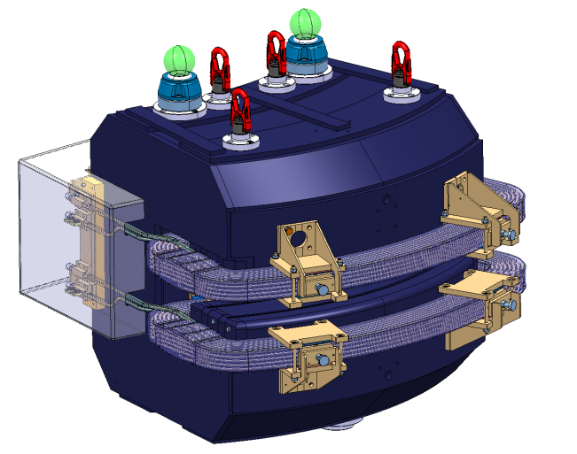

Figure 1. The MBR magnet for ELENA [2].

# DEFINITIONS

Central field: *B0*

Integral field: *∫Bdl*

Nominal current: *Inom**326 A*

Nominal *B0*: *Bnom* *0.420 T*

Nominal *∫Bdl: ∫Bdl at Inom 0.408 Tm*

# MEASUREMENT METHODS AND PROCEDURES

The measurement of the field in the aperture of curved magnets poses some challenges. There is not a unique technique that can respond to the requirements in terms of absolute accuracy, precision, and time resolution. Therefore, a set of different methods is selected for approaching these measurements. Specifically, we decided to use i) arrays of curved coils, ii) mapping with Hall probe, iii) NMR, iv) stretched wire, and v) curved wire.

## ARRAY OF COILS IN PULSED MODE

The measurement with an array of curved coils, often called fluxmeter, is selected because of the positive experience on similar magnets [2][3].

The fluxmeter for the ELENA dipoles is composed of a set of 9 equal induction coils embedded in a supporting structure made of a fiber-glass composite (Figure 2). Each coil is shaped to follow the ideal trajectory of the particles, assuming the hard-edge model for the field profile. The length is sufficient to fully cover the integral field along that trajectory. The coils are designed to be at a center-to-center distance of 11 mm and to have a straight length of 1.65 m. The windings of the coils are obtained by inserting 9 turns of a 66-strand Litz-wire cable (Figure 3) into a groove precisely-machined on the support structure. The wires are then connected in series by using custom connection boards placed on one side of the supporting structure (Figure 3), outside the field produced by the magnet. The relatively large number of turns is required to cope with the low rate of change of the field at which the magnets can be cycled. After the winding, a check is performed in one of the magnets, and then the cables are impregnated to assure the stability of their position over time.

The structure of the fluxmeter is made to be precisely positioned into the magnet by means of two mechanical interfaces that are in contact with the magnet end plates. Positioning holes are present to allow a second fluxmeter to be placed on top. Several combinations are possible and any coil of the top fluxmeter can be positioned on top of any coil of the bottom fluxmeter. This feature allows the cross calibration of coils of different fluxmeters and, at the same time, the measurement in different positions by using one single coil. In addition, the fluxmeter can be placed at different heights by means of some shimming plates with suitable thickness.

A measurement is carried out by i) positioning the fluxmeter in the magnet aperture, ii) ramping the magnet from 0 to *Inom*, and again to 0, while acquiring the voltage induced on one of the coils, iii) repeating the acquisition from a different coil or by displacing the fluxmeter in a different position. The flux can be retrieved by integrating the voltage over time. Given the knowledge of the effective width of the coil, the integrated field can be derived from the flux. A measurement of the current is performed in parallel and synchronously.

The position of the fluxmeter with respect to the magnet can be finely aligned by means of a laser tracker. Retroreflectors can be put in some reference holes present on the structure of the fluxmeter. Therefore, the position of the coils can be referred to the magnet fiducials.

The residual magnetization can be measured, with no current in the magnet, by acquiring the voltage while the fluxmeter is removed from the magnet aperture, flipped, and inserted again.

The advantages of this method are the following: i) the relatively easy procedure for the setup and the alignment, ii) the fast acquisition allowing measurements while the magnet is cycled, iii) the precise measurement of the integral field homogeneity, and iv) the accurate measurement of the absolute integral field if the coils are properly calibrated.

In total, 4 fluxmeters were produced: 2 for the series measurements, 1 for the BTrain, and 1 spare.

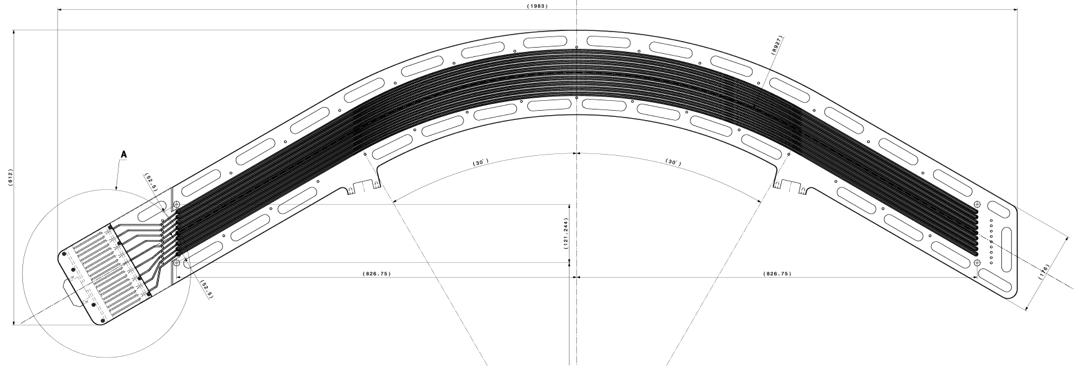

Figure 2. The fluxmeter for the ELENA dipoles: technical drawing [4].

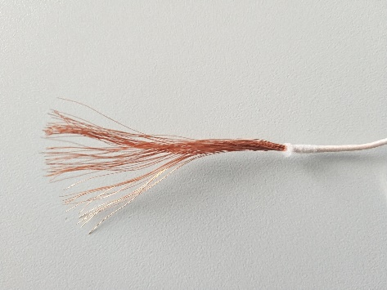 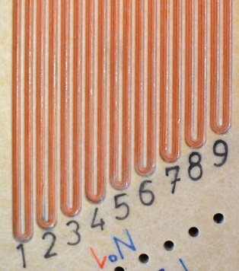 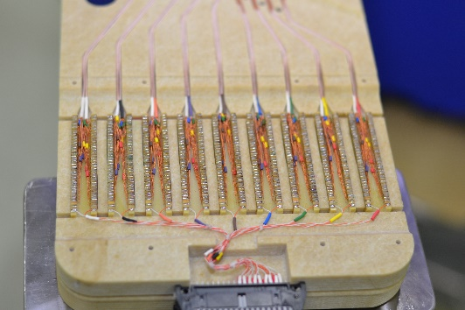

Figure 3. Some details of the fluxmeter: a) the Litz wire, b) the 9 coils and the positioning holes, and c) the connection box.

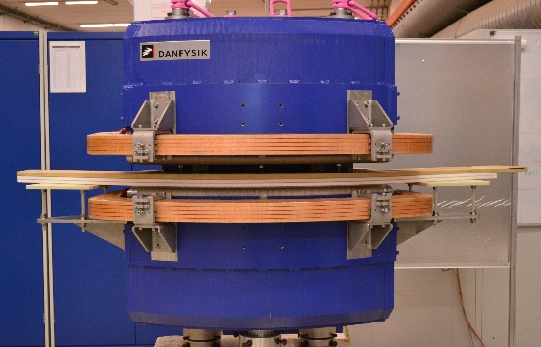 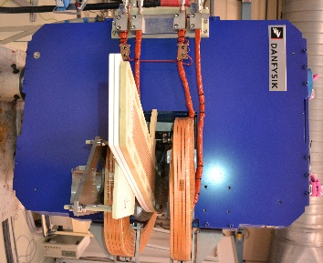 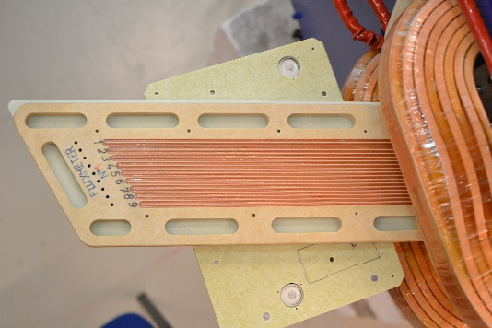

Figure 4. The fluxmeter in the ELENA dipole: a) front, b) side, and c) top views.

## HALL PROBE AND NMR TESLAMETERS

Hall probe and NMR teslameters are as well used for the characterization of the ELENA dipoles. For all tested magnets, a Hall probe teslameter is positioned on top of the fluxmeter and its analogue output acquired at the same time as voltage and current. This measurement provides the value of the central field that is required, together with the integral field given by the fluxmeter, for the estimation of the magnetic length.

The NMR teslameter, instead, is used occasionally for cross-calibration.

## 3D MAPPING

An automatic mapping system is used for the scanning of the field on a grid of points. The probe, based on a temperature-controlled Hall sensor fixed on a ceramic arm, is precisely positioned by means of translating axes operating next to the magnet. This type of measurement requires a relatively long time for the setup, the alignment, and the performance of the test. Therefore, it is used only for the pre-series magnet and only for mapping a grid of points on the mid-plane of the magnet aperture.

## STRETCHED WIRE

Some measurements are performed by using the stretched wire system. This technique provides an accurate measurement of the integral field along straight lines. It is used only for the pre-series magnet and mainly for cross-calibration purposes.

## CURVED WIRE

With the aim of developing new concepts, we tried some innovative techniques as well. The curved wire consists of a wire fixed in a groove on a rigid plate. The grove is precisely machined, by using a CNC machine, and follows the ideal particle trajectory. The plate is then attached to the same x-y tables used for the standard stretched wire. This allow the measurement the flux change on a curved trajectory instead of straight lines, as per the classical stretched wire. The method is interesting because it can provide the absolute integral field at different levels and at steady currents. Under the assumption of an accurate positioning of the wire on the curved trajectory, it does not require any cross-calibration with other systems. It is used only on the pre-series magnet and mainly for cross-calibration purposes.

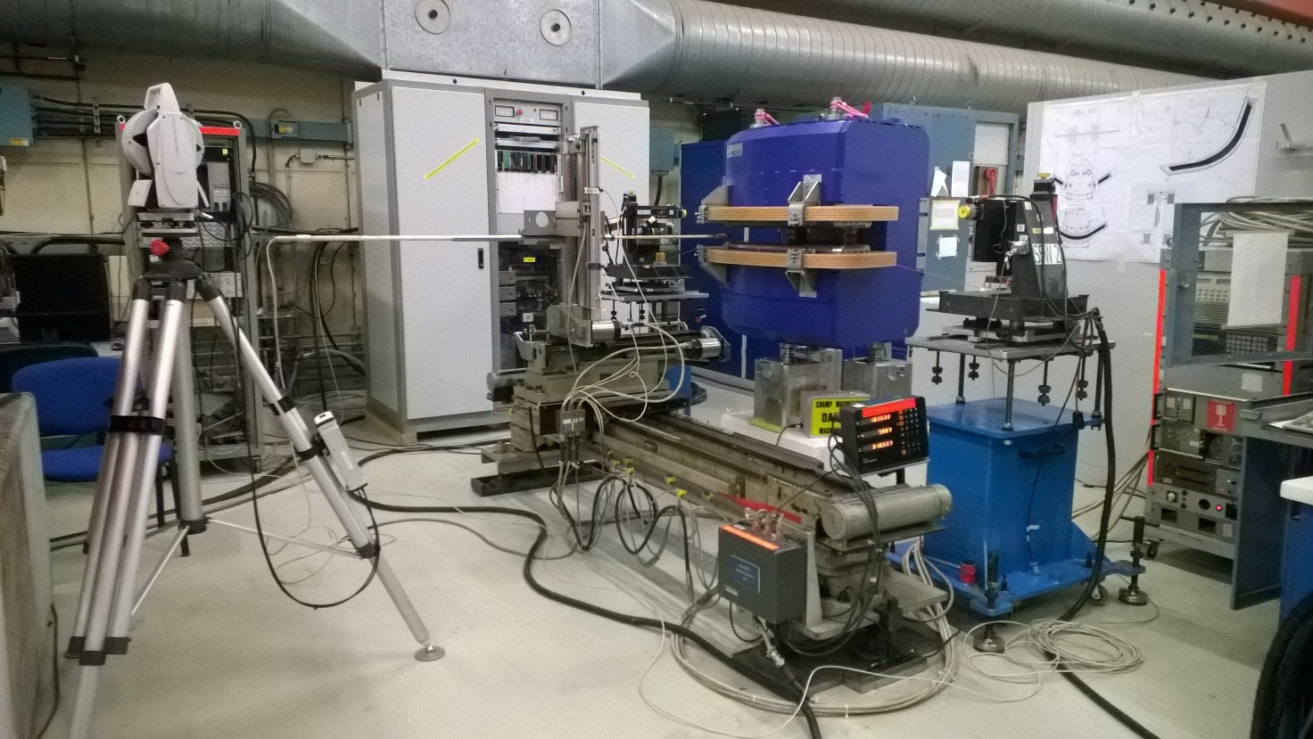

Figure 3. The measurement setup in bld. 375: the pre-series magnet is equipped with the 3D mapping system and the stretched wire stages. The laser tracker is visible on the left and the power converter on the back.

# CALIBRATION

## Calibration of the integraL field

An induction coil can provide accurate results only if its active surface is suitably calibrated. Usually this is done in a special dipole magnet with a wide aperture. The coil is flipped upside-down in the homogeneous field of the magnet aperture that was previously mapped by using an NMR teslameter.

The fluxmeter for the ELENA dipoles cannot be calibrated in such a way because no magnets with a suitable aperture are available. Therefore, a different calibration strategy is adopted. The calibration of the coil surfaces is performed “in situ” on the first MBR magnet under test. The absolute field of the magnet is measured at nominal current by using different techniques: the 3D mapping, the stretched wire, and the NMR for instance.

The sensor of the 3D mapping system is calibrated with respect to the NMR in a position close to centre of the magnet aperture. Figure 6 shows the results of the mapping of a grid of points laying on the midplane of the magnet aperture.

Then, the grid of points is cross calibrated with respect to the measurements given by the stretched wire: integrals on straight lines are computed from the grid and compared to the integrals directly measured by the wire at the same position.

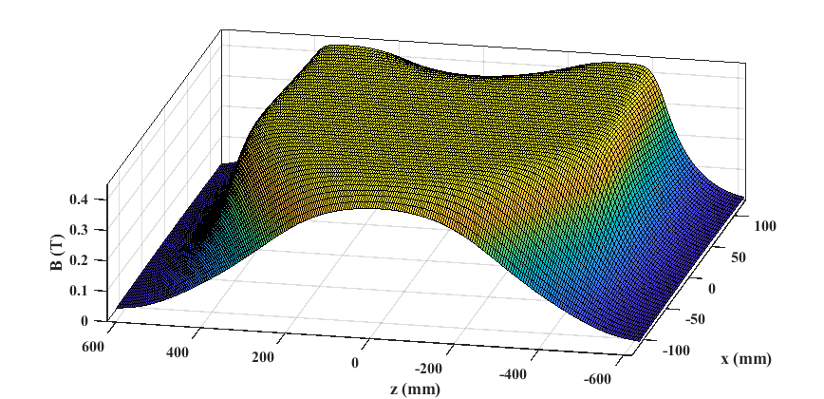

Figure 6. Results of the 3D mapping on the pre-series magnet.

Table 2. Cross-calibration coefficients.

|  |  |  |
| --- | --- | --- |
| **Cross calibration** | | |
| **Methods** | **Amplitude [-]** | **Positioning offset [mm]** |
| **Hall probe vs NMR** | 1.0011 | - |
| **Hall probe vs Stretched wire** | 0.9982 | 9 |
| **Numerical model vs Stretched wire** | 1.0030 | -2 |

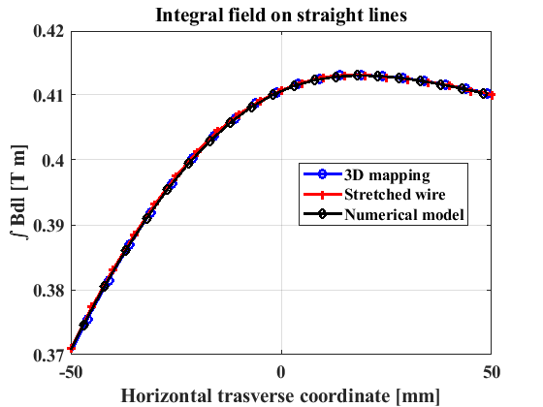

Figure 7. Comparison among the different methods for the integral field on straight lines as function of the horizontal coordinate after the cross calibration.

The coefficients of the cross calibration are reported in Table 2. Figure 7 shows the comparison of the integrals on straight lines, among the different methods, and after the cross calibration. The cross-calibration coefficients are in the range of ±0.3% and demonstrate a sufficient accuracy for the integral field on straight lines.

The calibrated grid of points is then used for computing the integrals on the curved trajectories. An additional contribution to the final uncertainty is introduced by this additional manipulation of the data.

## CALIBRATION OF THE FLUXMETER COILS

The integral on the trajectory passing through the magnet centre is taken as reference for the calibration of the fluxmeter coils.

Each coil of the different fluxmeters is positioned to cover the nominal trajectory. Then the flux change induced by ramping the magnet, from 0 to *Inom*, is acquired. The ratio of the measured flux and the reference integral field gives the calibration coefficient for the coil. Since the calibration is done considering the integral field strength, the coil “effective width” [m] is retrieved. It is the coefficient required for converting the measurement of the flux [Vs] to the integral field [Tm]. Table 2 reports the calibrated effective widths on 3 fluxmeters. Figure 7 shows the relative differences among the coils. The results demonstrate that there is a spread in the range ±1% on the surfaces from the same fluxmeter. Even larger differences are noticeable on coils from different fluxeters.

The fluxmeter n.4 (spare unit) was not available at the time of the “in situ” calibration.

Table 2. The calibrated “effective widths” of the fluxmeter coils.

|  |  |  |  |
| --- | --- | --- | --- |
| **Effective widths [m]** | | | |
| **Coil** | **Fluxmeter 1** | **Fluxmeter 2** | **Fluxmeter 3** |
| 1 | 2.8619 | 2.9132 | 2.8800 |
| 2 | 2.8458 | 2.8970 | 2.8645 |
| 3 | 2.8466 | 2.8962 | 2.8712 |
| 4 | 2.8339 | 2.8968 | 2.8616 |
| 5 | 2.8280 | 2.8773 | 2.8461 |
| 6 | 2.8206 | 2.8962 | 2.8457 |
| 7 | 2.8156 | 2.8836 | 2.8397 |
| 8 | 2.8076 | 2.8967 | 2.8419 |
| 9 | 2.8067 | 2.8650 | 2.8279 |

Figure 7. Results of fluxmeter calibration: differences among coils on the same fluxmeter.

# RESULTS OF THE MEASUREMENTS

The results can be organized in 3 main categories:

1. Main dipole field
2. Field homogeneity
3. Dynamic effects

## MAIN DIPOLE FIELD

The measurement of the main integral field is performed by using the fluxmeter. The central coil of the fluxmeter is positioned on the nominal trajectory passing through the magnet centre.

The Hall probe teslameter is used instead for the central field.

Each magnet is firstly demagnetized and then pre-cycled 5 times from 0 to *Inom*. Successively, the current, the voltage from the fluxmeter coil, and the signal from the teslameter are acquired synchronously during one additional cycle (Figure 9). The cycle is composed of a ramp from 0 to *Inom*, a plateau of 7 s at *Inom*, and a ramp back to 0. The ramp rate for both ramp-up and ramp-down is 200 A/s. Figure 9 shows the powering cycle. The values at the end of the plateau at *Inom* are taken as reference results.

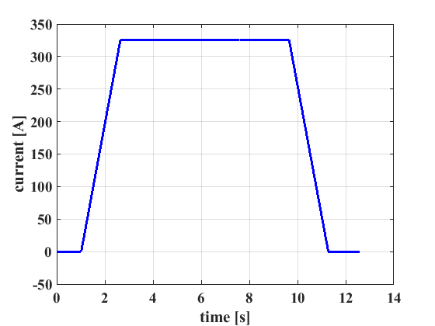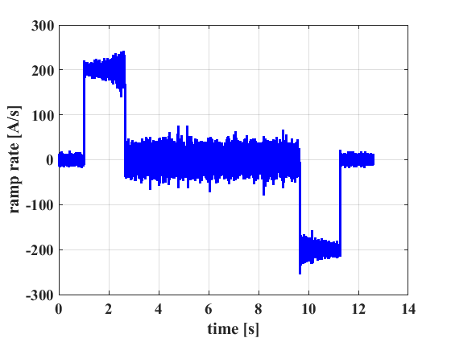

Figure 9. The powering cycle for the measurement of the main field.

### CENTRAL FIELD

The results of the measurements of the central field at nominal level are summarized in Table 4. The field strength in the centre of the magnets is 0.42802 T (±0.065%) on average. Figure 10 shows the central field as function of the current. We measured an additional spread of about ±0.05% at low field (<150 A). The pre-series magnet (DA000001) is not considered in the calculation of the average.

Table 4. The B0 measured on all magnets.

|  |  |  |  |
| --- | --- | --- | --- |
| **MAGNET** | **I** | **B0** | **Δ B0** |
|  | **[A]** | **[T]** | **[%]** |
| PXMBHEKCWP-DA000001 | 326.00 | 0.42866 | 0.15 |
| PXMBHEKCWP-DA000002 | 326.00 | 0.42786 | -0.04 |
| PXMBHEKCWP-DA000003 | 326.00 | 0.42802 | 0.00 |
| PXMBHEKCWP-DA000004 | 326.00 | 0.42789 | -0.03 |
| PXMBHEKCWP-DA000005 | 326.00 | 0.42820 | 0.04 |
| PXMBHEKCWP-DA000006 | 326.00 | 0.42804 | 0.00 |
| PXMBHEKCWP-DA000007 | 326.00 | 0.42837 | 0.08 |
| PXMBHEKCWP-DA000008 | 326.00 | 0.42780 | -0.05 |
| **Average (2 to 8)** |  | **0.42802** | **0.00** |
| **Max-Min (2 to 8)** |  | **0.00057** | **0.13** |

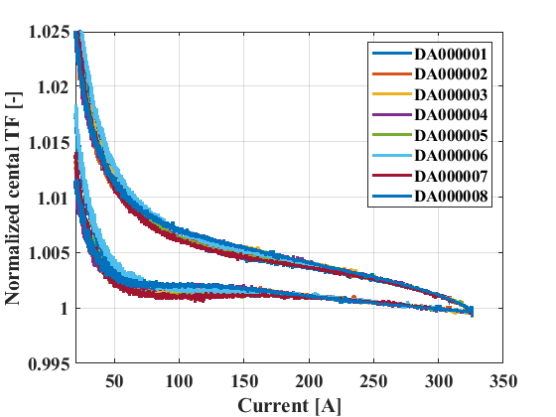

Figure 10. The normalized transfer function of the central field as function of the current.

### INTEGRAL FIELD

The magnets, after a preliminary measurement, are shimmed to bring their integral field as close as possible to the average value. The results of the final measurements of the integral field at nominal level are summarized in Table 5. The integral field strength of the magnets is 0.41546 Tm (±0.025%) on average. Figure 11 shows the integral field as function of the current. We measure an additional spread of about ±0.15% at lower field. The pre-series magnet (DA000001) shows larger discrepancies and therefore it is not considered in the calculation of the average.

Table 5. The ʃBdl measured on all magnets.

|  |  |  |  |  |
| --- | --- | --- | --- | --- |
| **MAGNET** | **Shim laminations** | **I** | **ʃBdl** | **Δ ʃBdl** |
|  |  | **[A]** | **[T m]** | **[%]** |
| PXMBHEKCWP-DA000001 | 0 | 326.00 | 0.41641 | 0.23 |
| PXMBHEKCWP-DA000002 | 4+4 | 326.00 | 0.41551 | 0.01 |
| PXMBHEKCWP-DA000003 | 4+4 | 326.00 | 0.41547 | 0.00 |
| PXMBHEKCWP-DA000004 | 4+4 | 326.00 | 0.41536 | -0.03 |
| PXMBHEKCWP-DA000005 | 3+3 | 326.00 | 0.41545 | 0.00 |
| PXMBHEKCWP-DA000006 | 3+3 | 326.00 | 0.41551 | 0.01 |
| PXMBHEKCWP-DA000007 | 3+3 | 326.00 | 0.41557 | 0.02 |
| PXMBHEKCWP-DA000008 | 4+4 | 326.00 | 0.41540 | -0.02 |
| **Average (2 to 8)** |  |  | **0.41546** | **0.00** |
| **Max-Min (2 to 8)** |  |  | **0.00021** | **0.05** |

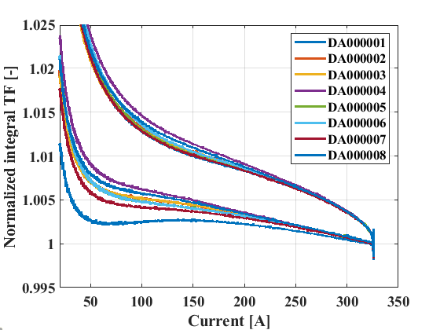

Figure 11. The normalized transfer function of the integral field as function of the current.

### MAGNETIC LENGTH

The magnetic length can be retrieved by combining the measurements of integral and central field. The results are summarized in Table 6. The magnetic length of the magnets is 970.7 mm (±0.05%) on average. The pre-series magnet (DA000001) is not considered in the calculation of the average.

Table 6. The magnetic length (Lm) measured on all magnets.

|  |  |  |  |
| --- | --- | --- | --- |
| **MAGNET** | **Shim laminations** | **Lm** | **Δ Lm** |
|  |  | **[mm]** | **[%]** |
| PXMBHEKCWP-DA000001 | 0 | 971.4 | 0.08 |
| PXMBHEKCWP-DA000002 | 4+4 | 971.1 | 0.05 |
| PXMBHEKCWP-DA000003 | 4+4 | 970.7 | 0.00 |
| PXMBHEKCWP-DA000004 | 4+4 | 970.7 | 0.01 |
| PXMBHEKCWP-DA000005 | 3+3 | 970.2 | -0.05 |
| PXMBHEKCWP-DA000006 | 3+3 | 970.7 | 0.01 |
| PXMBHEKCWP-DA000007 | 3+3 | 970.1 | -0.05 |
| PXMBHEKCWP-DA000008 | 4+4 | 971.0 | 0.04 |
| **Average (2 to 8)** |  | **970.7** | **0.00** |
| **Max-Min (2 to 8)** |  | **1.0** | **0.10** |

### REMANENCE

The remanence on the main integral field is measured at 0 current coming from *Inom* at a ramp rate of 200 A/s. The results are summarized in Table 7. The field remanence on the magnets is 0.65 mT m (±0.08 mT m) on average. The pre-series magnet (DA000001) is not considered in the calculation of the average.

Table 7. Remanence (Br) measured on all magnets.

|  |  |
| --- | --- |
| **MAGNET** | **Br** |
|  | **[mT m]** |
| PXMBHEKCWP-DA000001 | 0.75 |
| PXMBHEKCWP-DA000002 | 0.56 |
| PXMBHEKCWP-DA000003 | 0.67 |
| PXMBHEKCWP-DA000004 | 0.64 |
| PXMBHEKCWP-DA000005 | 0.63 |
| PXMBHEKCWP-DA000006 | 0.71 |
| PXMBHEKCWP-DA000007 | 0.73 |
| PXMBHEKCWP-DA000008 | 0.63 |
| **Average (2 to 8)** | **0.65** |
| **Max-Min (2 to 8)** | **0.17** |

## FIELD HOMOGENEITY

The field homogeneity, in terms of uniformity of the integrated field across the aperture, is measured by using the fluxmeter. A set of measurements at 9 different positions on the mid-plane is considered. The linear coefficient of a linear fit of the measurements as function of the horizontal position gives the gradient. The residuals of the fit contain the contribution to field homogeneity from the multipoles with order greater than the quadrupole (n>2). It must be noted that the coils are sensitive only to the vertical component of the field.

Table 8. The integral gradient (ʃGdl) measured on all magnets.

|  |  |
| --- | --- |
| **MAGNET** | **ʃGdl** |
|  | **T m / m** |
| PXMBHEKCWP-DA000001 | 0.2078 |
| PXMBHEKCWP-DA000002 | 0.2074 |
| PXMBHEKCWP-DA000003 | 0.2074 |
| PXMBHEKCWP-DA000004 | 0.2073 |
| PXMBHEKCWP-DA000005 | 0.2073 |
| PXMBHEKCWP-DA000006 | 0.2074 |
| PXMBHEKCWP-DA000007 | 0.2074 |
| PXMBHEKCWP-DA000008 | 0.2073 |
| **Average (2 to 8)** | **0.2074** |
| **Max-Min (2 to 8)** | **0.0001** |

### GRADIENT

The results of the measurements of the integral gradient are summarized in Table 8. The integral gradient of the magnets is 0.2074 T m/m (±0.025%) on average. The pre-series magnet (DA000001) is not considered in the calculation of the average.

### HOMOGENEITY

The results of the measurements of the integral field homogeneity are summarized in Table9 and shown in graphic form in Figure 12. The integral field homogeneity of the magnets is well within the requirements of ±2·10-4 in the region ±33 mm at *Inom*.

**Table 9. Measured integral field homogeneity at *Inom*.**

|  |  |  |  |  |  |  |  |  |  |
| --- | --- | --- | --- | --- | --- | --- | --- | --- | --- |
| **Position [mm]** | **-44** | **-33** | **-22** | **-11** | **0** | **11** | **22** | **33** | **44** |
| **MAGNET** | **dB/B0 on mid-plane [10-4]** | | | | | | | | |
| PXMBHEKCWP-DA000001 | 0.1 | -0.5 | -0.1 | 0.3 | 0.0 | -0.4 | -1.0 | -1.3 | 1.4 |
| PXMBHEKCWP-DA000002 | -0.8 | -0.8 | -0.3 | -0.2 | 0.0 | -0.8 | -1.0 | -1.2 | 0.0 |
| PXMBHEKCWP-DA000003 | -0.5 | -0.9 | 0.6 | 0.5 | 0.0 | 0.0 | -0.9 | -0.6 | 0.1 |
| PXMBHEKCWP-DA000004 | -1.6 | -1.0 | 0.2 | 0.5 | 0.0 | -0.3 | -1.1 | -1.2 | -0.6 |
| PXMBHEKCWP-DA000005 | -1.5 | -1.1 | 0.0 | 0.3 | 0.0 | -0.1 | -0.7 | -1.4 | -0.9 |
| PXMBHEKCWP-DA000006 | -1.7 | -1.2 | -0.1 | 0.2 | 0.0 | -0.1 | -0.6 | -1.1 | -1.4 |
| PXMBHEKCWP-DA000007 | -1.8 | -1.3 | 0.0 | 0.4 | 0.0 | -0.4 | -1.1 | -1.4 | -1.0 |
| PXMBHEKCWP-DA000008 | -1.4 | -0.8 | 0.2 | 0.4 | 0.0 | -0.2 | -0.8 | -1.0 | -0.6 |

Figure 12. Measured integral field homogeneity at *Inom*.

## DYNAMIC EFFECTS

Dynamic effects due to eddy currents are evaluated by using two methods: i) analysis of the field decay on the plateaus after ramps, and ii) by comparing the field during ramps at different ramp rates.

### DECAY AFTER RAMPS

The evaluation of the decay of eddy currents was performed only on the spare magnet (DA000002). For this test, the voltage induced on the fluxmeter coil is measured by using an acquisition system with a larger bandwidth (1 MS/s) with respect to the other tests. This is required to avoid delays on the flux signal that could affect the accuracy of the measurement. Figure 13 shows the powering ramps and the relative decays of eddy currents on a plateau at *Inom*. We measure effects in the order of:

* -0.10% at 96 A/s (full ramp in 3.40 s)
* -0.15% at 144 A/s (full ramp in 2.25 s)
* -0.25% at 287 A/s (full ramp in 1.15 s)

The accuracy of these results is affected by the non-perfect control of the current (overshot) at the end of the ramp.

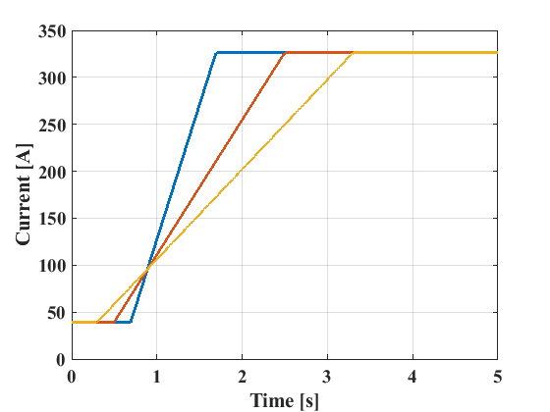 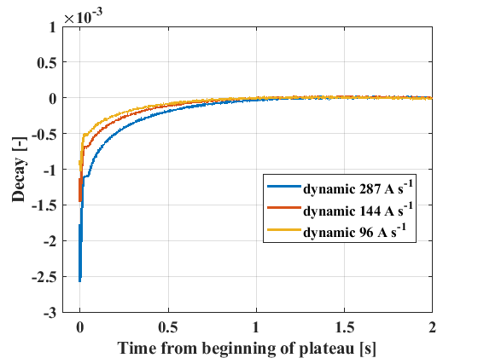

Figure 13. Measured dynamic effects from eddy currents on a plateau.

### RAMPS AT DIFFERENT RAMP RATES

The test of the eddy currents on ramps was performed on the spare magnet (DA000002) for the high ramp rates, and on the pre-series (DA000001) for steady currents. The acquisitions in dynamic conditions are the same as the evaluation of the decay and are done using an acquisition system with large bandwidth. The measurements at steady current are performed by using 3 different systems: fluxmeter and a fast acquisition card, fluxmeter and the standard integrator, and the curved wire.

Figure 14 shows the transfer function of the magnet at different ramp rates and in static conditions. The measurements in static conditions performed by using different systems and methods are in agreement. The measurements during the ramps clearly show the delay of the field, due to the eddy currents, that increases accordingly to the ramp rate.

Figure 15 shows the change of the transfer function versus the ramp rate at the intermediate field level of 200 A. The angular coefficient of the curve is smaller for the ramp-down for which, it seems, eddy currents have less time to fully develop. The results on the ramps are in general agreement with the results from the evaluation of the decays on the plateau.

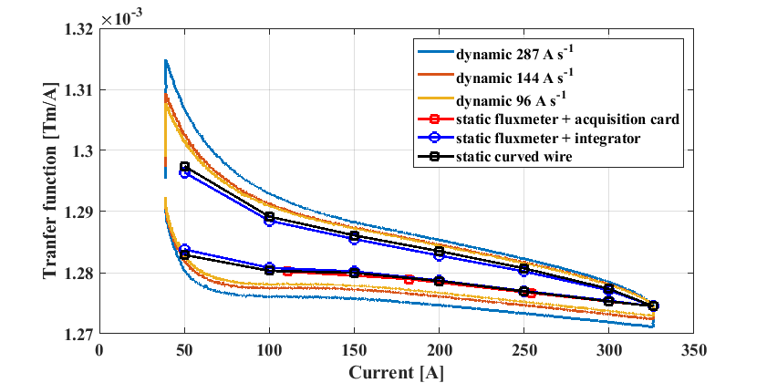

Figure 14. Measured dynamic effects from eddy currents on ramps.

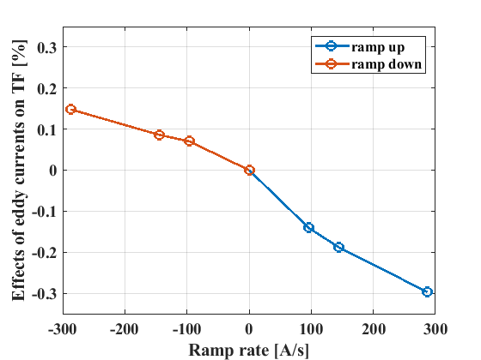

Figure 15. Effects of eddy currents on the main field as function of the ramp rate at an intermediate powering level of 200 A.

# CONCLUSIONS

We measured the 8 magnets PXMBHEKCWP to be used as main ring dipoles for ELENA. For the magnetic properties, the magnets resulted to be within tolerances. In particular:

* the average integral field at 326 A is 0.41546 Tm,
* the average central field at 326 A is 0.42802 T,
* the average magnetic length at 326 A is 970.7 mm,
* the average field remanence coming from 326 A is 0.65 mT m,
* the average gradient at 326 A is 0.2074 Tm / m,
* the field homogeneity at 326 A is within ±2·10-4,
* the effect of eddy currents on the main field is -0.10% at 96 A/s.

# REFERENCES

1. <https://norma-db.web.cern.ch/magdesign/idcard/1061/>
2. LNA-MBHEK-ER-0001, DESIGN REPORT ELENA Bending Magnet [PXMBHEKCWP (MBR)], EDMS 1311860
3. <https://public.cells.es/workshops/immw17.cells.es/presentations/Tue08-IMMW17-ABeaumont.pdf>
4. “PCB coil array for measuring curved accelerator dipoles: two case studies on the MedAustron accelerator”, 20th IMEKO TC4 International Symposium and 18th International Workshop on ADC Modelling and Testing, Benevento, Italy, September 15-17, 2014
5. Fluxmeter drawings

# APPENDIX A. Calibration curves for the main field